Instructions for the PGSA Team Sites
- Log into your account
Click Here
- Click on the link to go to your team Site

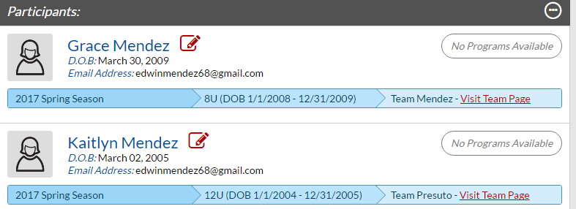

- From your Team home page you can:
  - See your “Roster”
  - See your “Calendar” which will eventually have your schedule. The Functionality is also here to set up practices and to keep game or practice attendance.
    - To set up a practice click Calendar and then click the “Create Event” button.
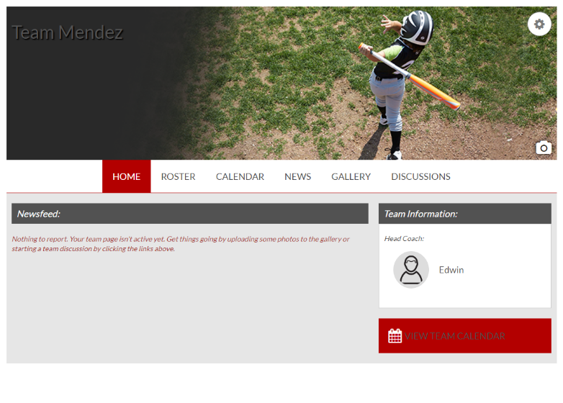
  - Add “News”
  - Add pictures to your “Gallery”
  - Or start team “Discussions”
  - Click the camera to put in a unique team picture
  - We are even trying to get sponsorship for each team, and they will have their logos on here.

- Rosters - If you play around with the rosters, you can put in uniform numbers and make lineups. You can print rosters out (not pretty, but functional).
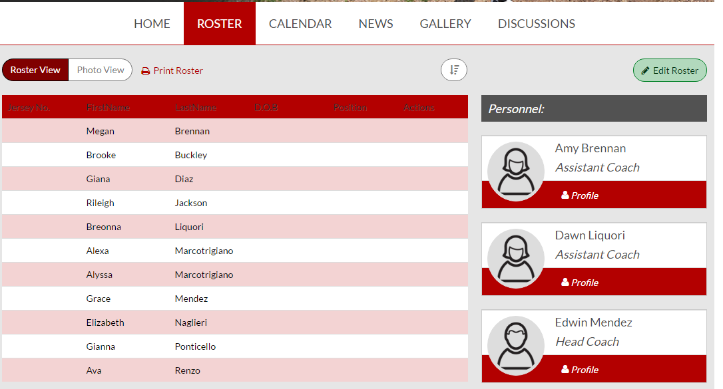
- When we have them, your schedules will be under the Calendar tab.
- Download the app!!
