Instructions for the Protect Youth Sports background check

- Goto https://opportunities.averity.com/PlainedgeGSA
- First Screen – Summary of rights, yes/no to proceed.
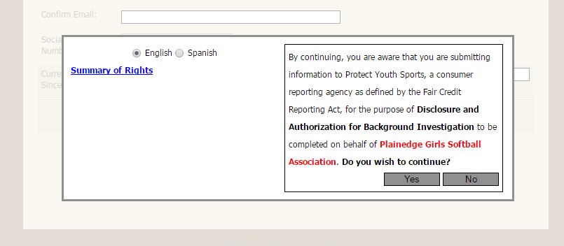
- Second Screen – Enter your information
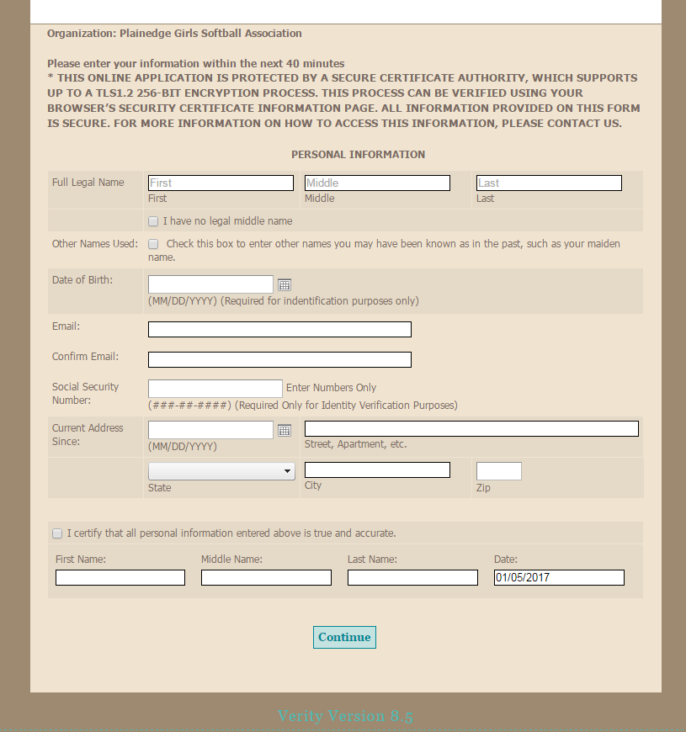
- Third Screen – Disclosure and Authorization Screen
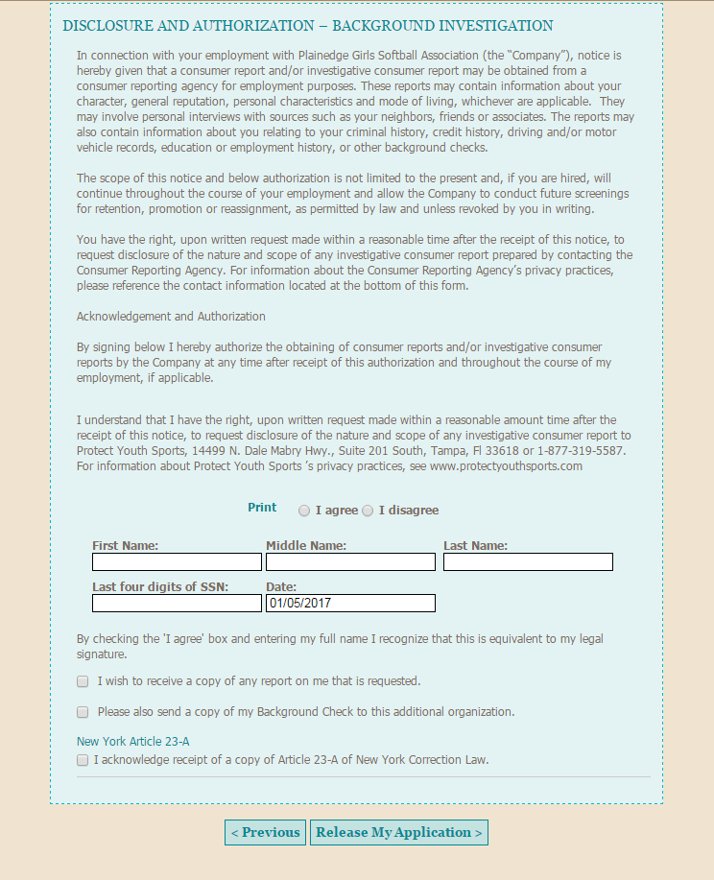
- Fourth Screen – Enter Credit Card info to pay $12.00
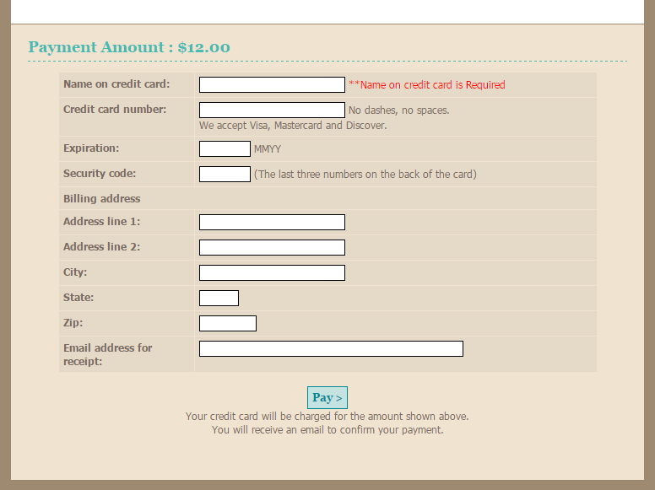
- Fifth Screen – Acknowledgement of Application Completion
